Hi I’m using Oracle 10g and forms 6i

Details of form version is mention below:
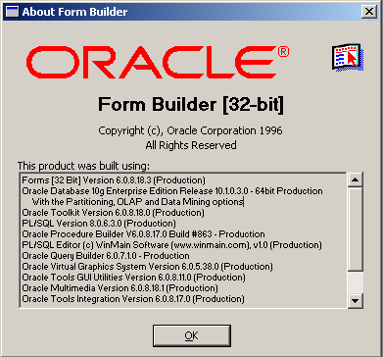

I created a TABLE IMAGES whose script is mentioned below:

CREATE TABLE IMAGES
(
IMAGE_NAME VARCHAR2(30) primary key,
MIME_TYPE VARCHAR2(30),
CONTENT BLOB
)

And I created a DIRECTORY also as:

create or replace directory SOURCE_DIR as '/home/citils/mit';

After that I INSERTED data in the table using following Procedure:

PROCEDURE load(filename VARCHAR2) AS
f_lob BFILE;
b_lob BLOB;
image_name VARCHAR2(30);
mime_type VARCHAR2(30);
dot_pos NUMBER;
BEGIN
dot_pos := INSTR(filename,'.');
image_name := filename; --SUBSTR(filename,1,dot_pos-1);
mime_type := 'image/'||SUBSTR( filename,dot_pos+1,length(filename) );
INSERT INTO images values(image_name,mime_type,empty_blob() )
RETURN content INTO b_lob;
f_lob := BFILENAME('SOURCE_DIR',filename);
dbms_lob.fileopen(f_lob,dbms_lob.file_readonly);
dbms_lob.loadfromfile(b_lob,f_lob,dbms_lob.getlength(f_lob) );
dbms_lob.fileclose(f_lob);
COMMIT;
Exception
when others then
dbms_output.put_line('Inside Exception: '||SQLERRM);
End;

Now after this if I want to DISPLAY these images in Oracle Forms then how can I do that?

Apart from these all stuffs if I’m creating a form with earlier mentioned IMAGES table with all default settings.
And after that I’m storing some data including Image file in that table using read_image_file( ) function.
After Storing these data in that table if I’m going to view these data it’s giving me following error.
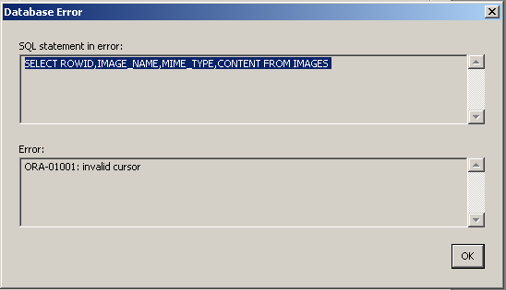

Even In Status bar it’s showing me following message:

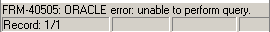

My screen Is looking like follwing photo:
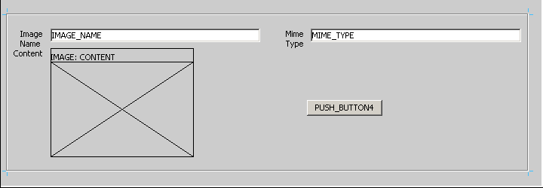

And the code for PUSH_BUTTON4 is mentioned below:
Under WHEN-BUTTON-PRESSED trigger
read_image_file(:IMAGES.IMAGE_NAME,'BMP','IMAGES.CONTENT');

Could u pls tell me any possible solutions to display Images in Forms from BLOB field?

