1. I restart all the services, i.e. control panel->Administrative Tools->Services (Local)

2. I applied listener status, it shows as follows;

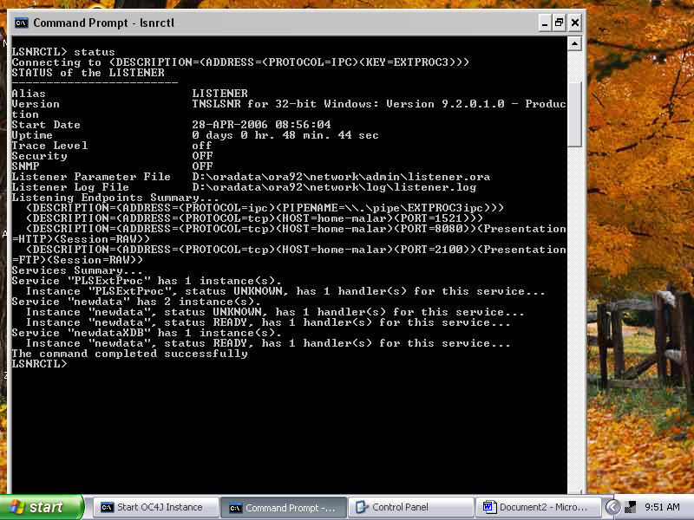

3. I started OC4J Instance, It displayed Oracle9iAS<9.0.2.0.0> Containers for J2EE initialized and no further process executed. So i exit the window.
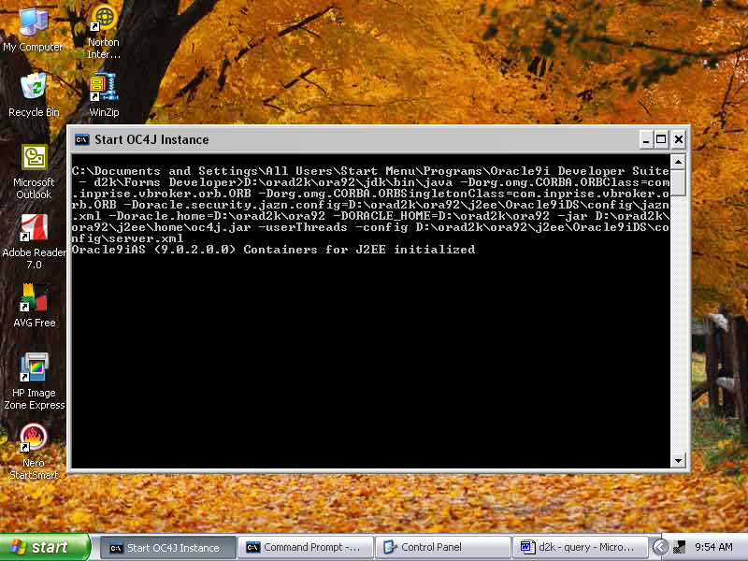

4. In the preference window, I select set default, it automatically shows a path http://home-malar:8888/forms90/f90servlet. selected ok & exit .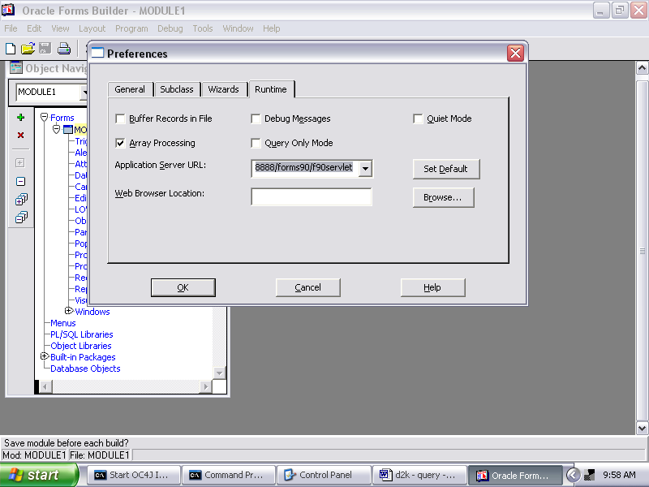

5. Here what I suppose to do? There is no active control to run in files on my computer.

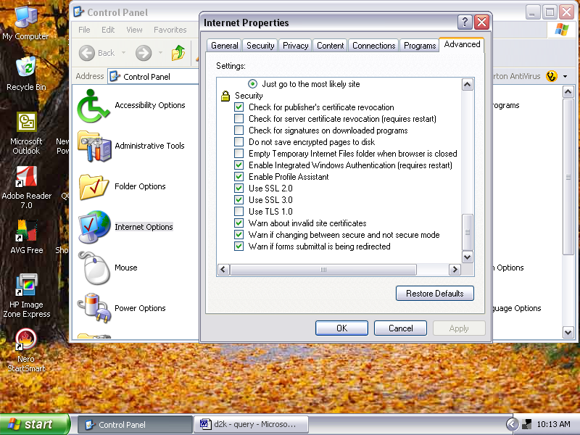

The error still occurred. I m not able 2 solve this. Pls give solution for this.
